Github link: - https://github.com/Princekush566/tudedude/tree/main
1. Frontend (Node.js with Express):
- Create a frontend using Express and Node.js.
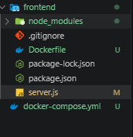
- Include a form similar to the one from the Flask Assignment 2.
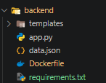
- Configure the form to send a request to the Flask backend.
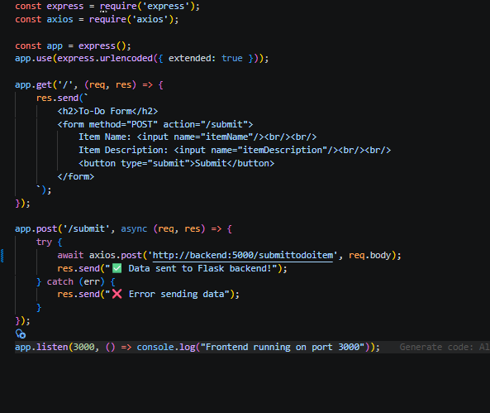

- Backend (Flask):
- Use the Flask backend to handle the form submission and process the data.
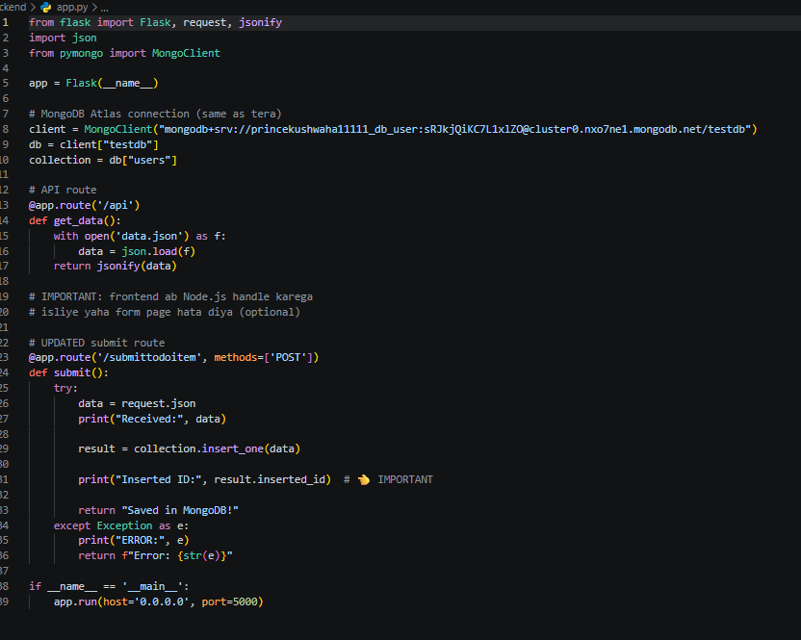
- Folder Structure:
- Organize the project with separate folders for the frontend and backend.
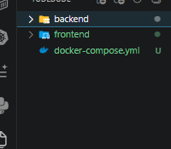
- Docker Configuration:
- Create a Dockerfile for both the frontend and backend.
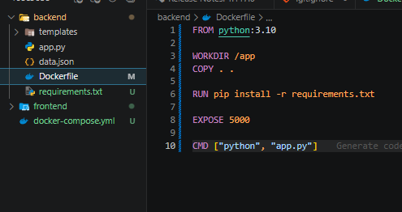
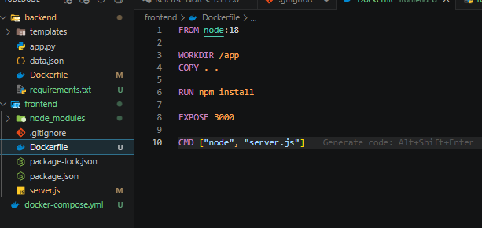
- Write a .yaml file (Docker Compose) to connect both services in the same network.
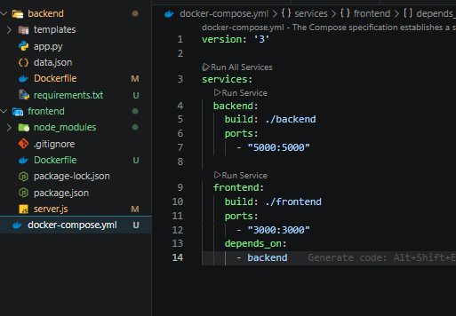
- Upload both images to docker hub and push your whole code to github and add the node_modules and other non required files(.vscode) in .gitignore
